**GARAGE MANAGEMENT SYSTEM**

**PROJECT SCREENSHOTS**

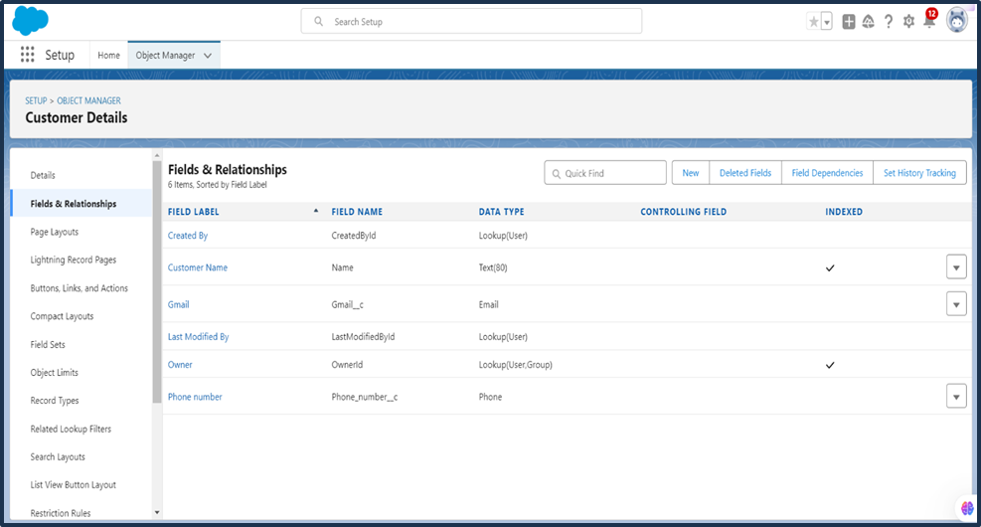

**Fig 1.1 Object Manager – Customer details**

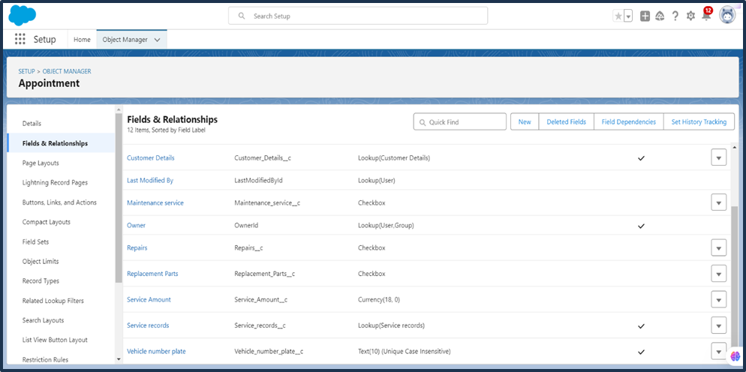

# Fig 1.2 Object Manager Appointment details

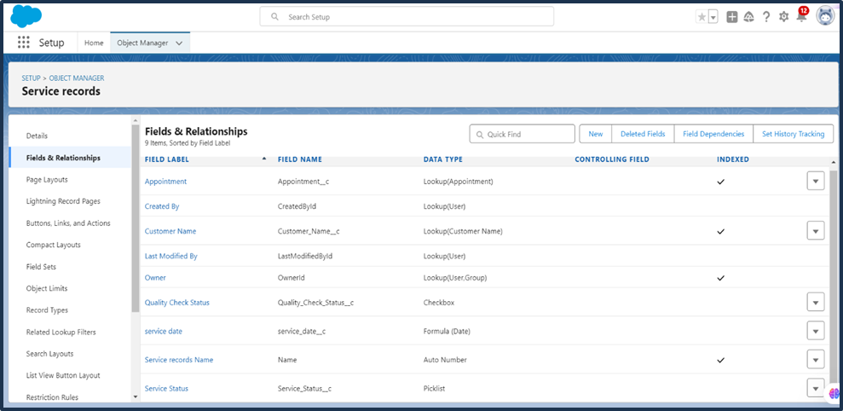

# Fig 1.3 Object Manager Service records details

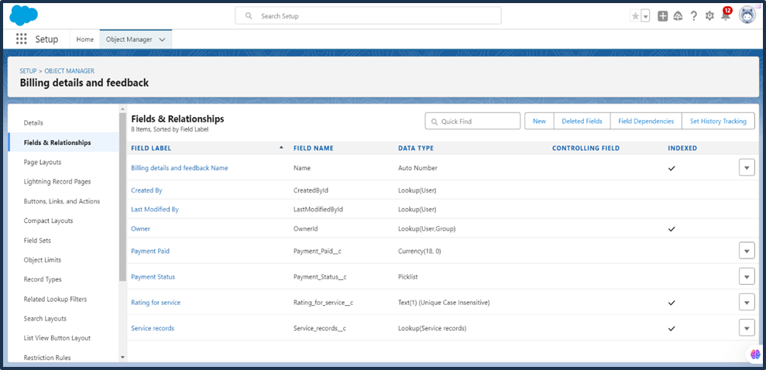

**Fig 1.4 Object Manager Billing details and Feedback**

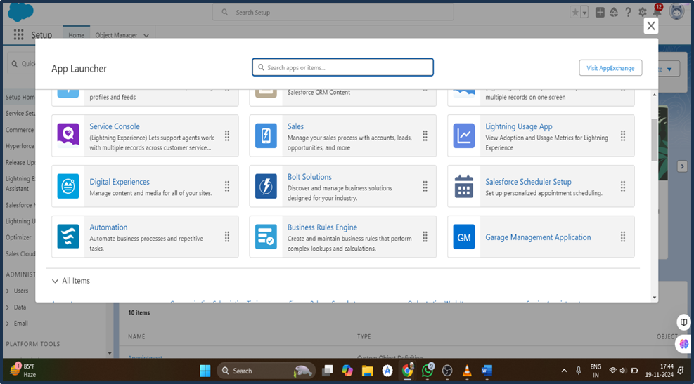

# Fig 1.5 The Lightning app launcher of Garage Management System

# Fig 1.6 Work Flow of the Custom Objects

**Fig 1.7 Apex class – AmountDistributionHandler**

**Fig 1.8 Apex Trigger - AmountDistribution**

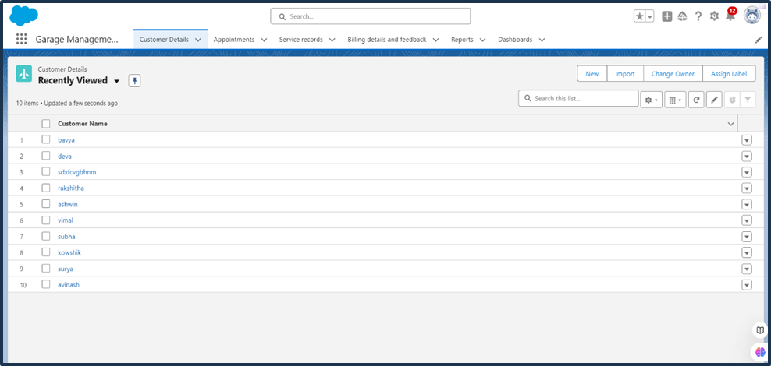

**Fig 1.9 Customer details in GMS**

**Fig 1.10 Appointments Details in GMS**

**Fig 1.11 Service Records in GMS**

**Fig 1.12 Billing and Feedback Details in GMS**

**Fig 1.13 New Service Information Reports in GMS**

**Fig 1.15 Performance Analysis using Line Chart**